The IB Diploma Programme (grades 11/12) has specific requirements.

IB Diploma programme
PROGRESSION CHART

- 3 SL (Standard Level) and 3 HL (Higher Level) courses. (or 2 SL and 4 HL)
- Students must have 1 class in each of group 1-5; the 6th course can be from any group 1-6.
- Most courses require 2 years as part of the Diploma Programme.
IB Group |  |  | 9th Grade | 10th Grade | 11th Grade | 12th Grade
IB Core | All DP students must take |  | *Students are encouraged to earn 100 hours of community service prior to Junior year for Florida Bright Futures scholarship. |  | Theory of Knowledge 1  (0900800) | Theory of Knowledge 2  (0900810)
Group 1 | Language A  English Literature |  | Pre-IB English 1  (1001800) | Pre-IB English 2  (1001810) | IB English Lit 3  (1001820)  IB English (CP) Lang & Lit 1  (1005850) | IB English Lit 4  (1001830)  IB English (CP) Lang & Lit 3  (1005856) | HL  HL
Group 2 | Language B  Language Acquisition |  | Pre-IB Spanish 1 or 2  (0708800) (0708810)  Pre-IB French 1  (0701800) | Pre IB Spanish 2 or 3 (0708810) (0708820)  Pre-IB French 2  (0701810) | IB Spanish 4 (0708830)  IB French 4  (0701830) | IB Spanish 5 (0708840)  IB French 5  (0701840) | SL  SL
Group 3 | Individual & Society Social Sciences |  | AP Human Geography  (2103400) | World History Honors  (2109320) | IB History of the Americas 1 (2100800)  IB Psychology 2  (2107810) – SL  Take Jr or Sr year | IB Contemporary History 2  (2109805)  IB Psychology 3  (2107820) – HL ONLY | HL  SL (1yr) HL(2yr)
Group 4 | Experimental Sciences |  | Pre-IB Biology 1 | Chemistry Honors (2003350)  Physics Honors  (2003390) | IB Biology 1 (2000805)  IB Chemistry 1  (2003805)  IB Physics 1 (2003840) | IB Biology 3 (2000820)  IB Chemistry 3  (2003820)  IB Physics 2  (2003845) | HL  HL  SL
Group 5 | Mathematics (3 options) | Math Studies | Alg 1/Geo Honors  (1200320/1206320)  Alg 1/Geo Honors  (1200320/1206320)  Geo/Alg 2 Honors  (1206320/1200340) | Alg 2 Honors  (1200340)  Alg 2 Honors  (1200340)  Pre-IB Pre-Calculus  (1202340H) | IB Math Studies  (1209800)  IB Pre-Calculus  (1202370)  AP Calculus BC  (1202320) | IB Stats/Diff Calc (1210310)  IB Calc/Des Stat  (1202810)  IB Mathematics  (1209830) | SL
 |  | Math SL |  |  |  |  | SL
 |  | Math HL |  |  |  |  | HL
Group 6 | The Arts |  | Digital Info Tech  (8207310)  Or Another Elective | Another Elective  *If looking to take IB Visual Arts consider taking an art class *If looking to take IB Music consider taking AP music theory or a music performance course | IB Visual Arts 2  (0114825)  Take Jr or Sr year  IB Music 1  (1300816)  IB Film Studies 1  (0107470) | IB Visual Arts 3  (0114835) – HL ONLY  IB Music 2  (1300818)  IB Film Studies 3  (0107474) | SL (1yr) HL(2yr)  SL  HL
The IB Career-Related Programme

IB career-Related programme
PROGRESSION CHART
- VHS offers 2 career paths – Engineering and Medical
- Students must apply for the program
- Some of these courses are only offered to students in the program.

Engineering | 9th Grade | 10th Grade | 11th Grade | 12th Grade
Career Classes | Applied Engineering Tech 1  (8401110) | Applied Engineering Tech 2  (8401120) | Applied Engineering Tech 3  (8401130) | Advanced Tech Applications  (8601900)
Career Classes |  |  | Personal & Professional Skills 1  (1700820) | Personal & Professional Skills 2  (1700830)
IB Requirement |  |  | 1 IB 2 Year Course
IB Requirement |  |  | 1 Other IB Course (1 year or 2 year)
*Please look at the Diploma Programme for options of IB courses to take.
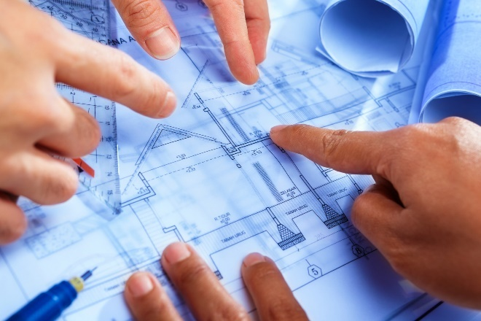
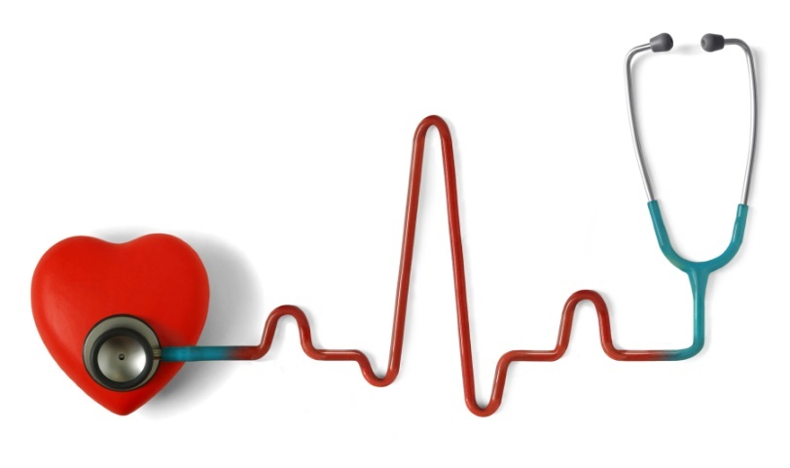

Medical | 9th Grade | 10th Grade | 11th Grade | 12th Grade
Career Classes | Medical Skills and Services  (8400320) | Health Science Anatomy & Physiology  (8417100) | Health Science Foundation (8417110) | Electro Cardio Tech 3 – EKG Technician (8427130)
Career Classes |  |  | Personal & Professional Skills 1  (1700820) | Personal & Professional Skills 2  (1700830)
IB Requirement |  |  | 1 IB 2 Year Course
IB Requirement |  |  | 1 Other IB Course (1 year or 2 year)
*Please look at the Diploma Programme for options of IB courses to take.

