IB Mission Statement  The International Baccalaureate® aims to develop inquiring, knowledgeable and caring young people who help to create a better and more peaceful world through intercultural understanding and respect.  To this end the organization works with schools, governments and international organizations to develop challenging programmes of international education and rigorous assessment.  These programmes encourage students across the world to become active, compassionate and lifelong learners who understand that other people, with their differences, can also be right. | Kathleen Jones  IB Coordinator | 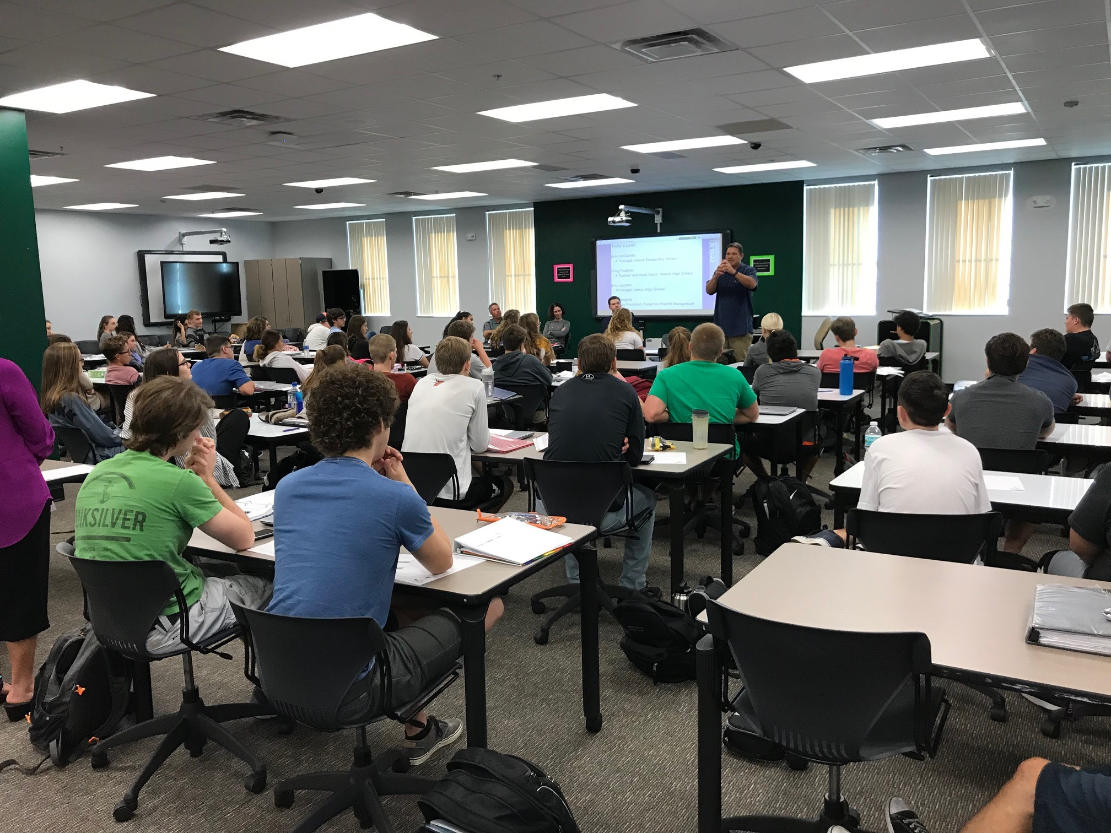 | VHS IB Diploma Program  - A quick look at the IB program at Venice High School  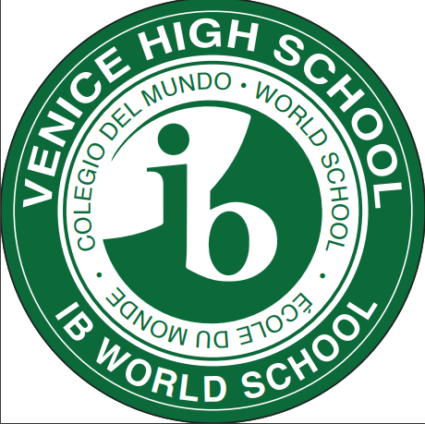  Visit our website:  vhsibprograms.com  @vhsibprogrammes

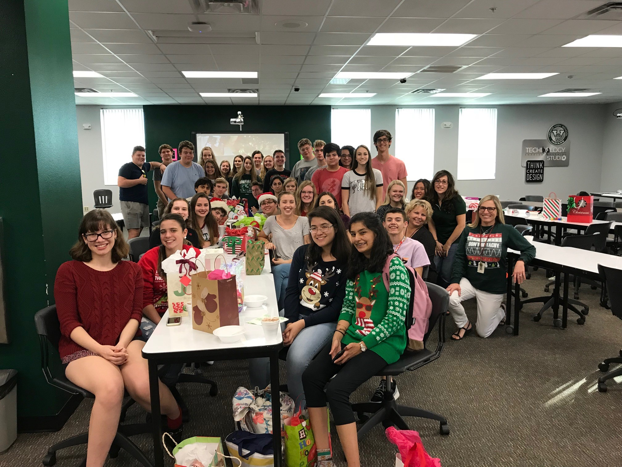  Why IB?  - IB is a “program” of studies- meaning it’s about developing skills in all areas- both in and out of the classroom.  - Students take IB for a few key reasons:  - To challenge themselves in academics  - To develop skills in all learning areas  - To belong to a school-based and international community  Prerequisites (by end of grade 10)  - 3 or higher on FSA Reading  - Complete Algebra II Honors  - Finish year two French or Spanish  - Consistent attendance record | “IB students have taken responsibility for their own learning…and have expanded their learning beyond academic study”  -College of Wooster  Statistics About IB  - A study at the University of California found that IB students earned higher GPAs and graduated at higher rates than those who hadn’t taken IB.  - IB students’ acceptance rate into colleges is 22% higher than those not in IB.  - The vast majority of top colleges and universities accept scores for IB Diplomas and Certificates for college credit. Students can earn up to 30 credits!  - 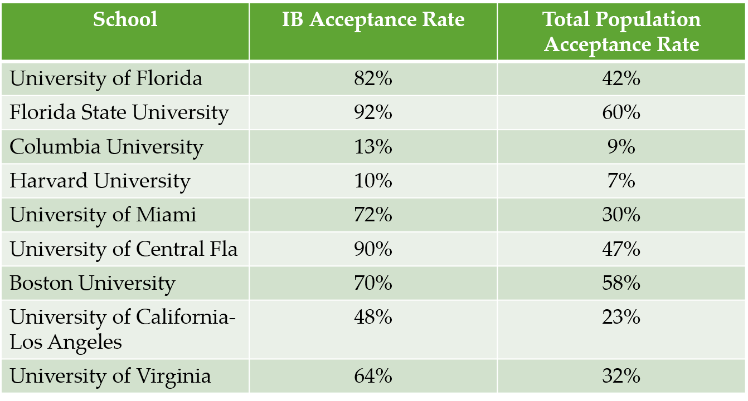 | IB Courses Available  IB courses are offered in six different groups of content. Students take a minimum of one course from each group. Instead of a Group 6 class, students can opt to take a second course in another subject.  Groups  Group 1: IB Literature  Group 2: IB Spanish or French  Group 3: IB History of the Americas, Psychology, or Business Mgmt  Group 4: IB Biology, Chemistry, Physics  Group 5: IB Math- 3 courses available  Group 6: IB Music, Art, or Film Study  Core: Theory of Knowledge, Extended Essay, CAS (Creativity, Activity, Service)  Contact VHS IB  Kathleen Jones  IB Coordinator  Kathleen.Jones@ sarasotacountyschools.net  Website

